****

**Tribhuvan University**

**Faculty of Humanities and Social Sciences**

**“Electronic Gadgets Store”**

**A Project Report**

**Submitted to:**

**Department of Computer Application**

**Lumbini City College**

***In the partial fulfillment of the requirement for the Bachelor of Computer Application***

**Submitted by:**

Rashish Regmi (6-2-1134-50-2020)

Pushpanjali Dewan (6-2-1134-49-2020)

**Under the Supervision of**

**Mr.** **Suraj Kumar Khatri**

# ACKNOWLEDGEMENT

Firstly, we would like to thank Lumbini City College for providing us this platform to gain knowledge about different aspects of Computer Science and Information Technology to explore our interest and ideas in the software development field through this project. We would also like to thank our Academic Coordinator **Mr. Bishal Kandel** who played an important role in providing us advice and suggestion towards the selection of our project and topic as well as for providing us with necessary content and classes regarding the project. We are also grateful for the valuable time, suggestion, help, support, supervision, and guidance support from our supervisor **Mr. Suraj Kumar Khatri** for providing with all necessary suggestions and corrections that are needed to be done for our project. In addition, we also want to thank our friends and classmates for helping us directly or indirectly with the guidelines we needed during the completion of our project.

# ABSTRACT

This project report aims to fulfill the requirements for the Bachelor of Computer Application. Our team takes pleasure in presenting the detailed project report that reflects our efforts in this semester. This project involves design and framework for an executing complex system i.e. “**Electronic Gadgets Store**” is a website, is an online platform store that provides a wide range of products for customers seeking high-quality and affordable goods and services which is related with customer.

The Electronic Gadgets Store offers a convenient way for customers to browse and purchase electronic products. The platform provides a user-friendly interface that enables customers to search for products by recipient, or budget, and offers a wide selection of items that cater to different tastes and preferences. As we know in this time going to physical store is difficult due to current situation, so we decided to research to build the offline shop into online, where the process is divided into threads and accordingly the threads are executed. The output reports are generated by the admins. Initially the administrators should also verify their identity by providing the required credentials and then administrator adds the list of products and its stocks and other details. Now the administrator can manage the Stocks and can see the transaction too. Additionally, a record of all the operations performed by either of the log geris maintained in a log file.

Table of Content

[ACKNOWLEDGEMENT ii](#_Toc178318039)

[ABSTRACT iii](#_Toc178318040)

[List of Abbreviations vi](#_Toc178318041)

[List of Figures vii](#_Toc178318042)

[List of Tables viii](#_Toc178318043)

[Chapter 1: Introduction 1](#_Toc178318044)

[1.1 Introduction 1](#_Toc178318045)

[1.2 Problem Statement 1](#_Toc178318046)

[1.3 Objectives 2](#_Toc178318047)

[1.4 Scopes and Limitation 2](#_Toc178318048)

[1.5 Report Organization 3](#_Toc178318049)

[Chapter 2: Background Student and Literature Review 4](#_Toc178318050)

[2.1 Background Study 4](#_Toc178318051)

[2.1.1 Study of an existing system 4](#_Toc178318052)

[2.2 Literature Review 4](#_Toc178318053)

[Chapter 3: System Analysis and Design 5](#_Toc178318054)

[3.1 System Analysis 5](#_Toc178318055)

[3.1.1 Requirement Analysis 5](#_Toc178318056)

[3.1.2 Feasibility Study 7](#_Toc178318057)

[3.1.3 Data Modeling(ER-Diagram) 8](#_Toc178318058)

[3.1.4 Process Modeling (DFD) 8](#_Toc178318059)

[3.2 System Design 10](#_Toc178318060)

[3.2.1 Architectural Design 10](#_Toc178318061)

[Figure 7: Working mechanism of the proposed System 10](#_Toc178318062)

[3.2.2 Database Schema 10](#_Toc178318063)

[Chapter 4: Implementation and Testing 12](#_Toc178318064)

[4.1 Implementation 12](#_Toc178318065)

[4.1.1 Tools Used (CASE tools, Programming languages, Database platforms) 12](#_Toc178318066)

[4.1.2 Implementation Details of Modules 12](#_Toc178318067)

[4.2 Testing 13](#_Toc178318068)

[4.2.1 Test Cases for Unit Testing 13](#_Toc178318069)

[4.2.2 Test Cases for System Testing 14](#_Toc178318070)

[Chapter 5: Conclusion and Future Recommendations 15](#_Toc178318071)

[5.1 Lesson Learnt/ Outcome 15](#_Toc178318072)

[5.2 Conclusion 15](#_Toc178318073)

[5.3 Future recommendations 15](#_Toc178318074)

[Appendices 17](#_Toc178318075)

# List of Abbreviations

DFD – Data Flow Diagram

ER-Diagram – Entity Relationship Diagram

IDE – Integrated Development Environment

Mongo DB – Mongo Database

MS-Office – Microsoft Office

Node.js – Node java script

VS-Code – Visual Studio Code

# List of Figures

[Figure 1: Use Case 6](file:////Users/mac/Desktop/final.docx#_Toc177298277)

[Figure 2: Gantt Chart 7](file:////Users/mac/Desktop/final.docx#_Toc177298278)

[Figure 3: ER-Diagram 8](file:////Users/mac/Desktop/final.docx#_Toc177298279)

[Figure 4: Zero Level DFD 8](file:////Users/mac/Desktop/final.docx#_Toc177298280)

[Figure 5: First Level DFD 9](file:////Users/mac/Desktop/final.docx#_Toc177298281)

[Figure 6: Second Level DFD 9](file:////Users/mac/Desktop/final.docx#_Toc177298282)

[Figure 7: Architecture Design 10](file:////Users/mac/Desktop/final.docx#_Toc177298283)

# List of Tables

[Table 1: Orders 10](#_Toc177318297)

[Table 2: Categories 10](#_Toc177318298)

[Table 3: Product .11](#_Toc177318297)

[Table 4: Users………………………………….….………………………………….…...11](#_Toc177318298)

[Table 5: Test Cases for Unit Testing 13](#_Toc177318297)

[Table 6: Test Cases for System Testing 14](#_Toc177318298)

# Chapter 1: Introduction

## 1.1 Introduction

In the digital age, the demand for convenient, reliable, and diverse shopping experiences has surged. Recognizing this need, we propose the development of an e-commerce site named **Electronic Gadgets Store**. This platform aims to revolutionize the way consumers shop for electronic gadgets by providing a seamless, user-friendly, and comprehensive online shopping experience.

**Electronic Gadgets Store** will provide to a wide range of customers, from tech enthusiasts to everyday consumers, offering an extensive catalog of the latest gadgets, including smart phones, laptops, tablets, and accessories. Our mission is to create a one-stop shop for all electronic needs, ensuring that customers have access to the best products at competitive prices. The project will focus on delivering an intuitive and interactive user interface, robust backend support for secure transactions, and efficient logistics for timely delivery. Additionally, we will implement advanced features such as personalized recommendations, detailed product reviews, and a responsive customer service system to enhance the overall shopping experience.

By leveraging the latest technologies and industry best practices, **Electronic Gadgets Store** aims to become a leading name in the e-commerce space, providing customers with unparalleled convenience, variety, and satisfaction in their gadget shopping journey.

## 1.2 Problem Statement

1. **Limited Product Accessibility**: Consumers struggle to find a wide range of electronic gadgets in one place, as physical stores often lack complete inventory, leading to inconvenience and missed opportunities.
2. **Time-Consuming Shopping**: Shopping for electronic gadgets in physical stores requires visiting multiple locations to compare prices, features, and availability, making the process time-consuming.
3. **Inconsistent Pricing and Deals**: Without a centralized platform, customers might miss out on competitive pricing and exclusive deals, resulting in higher costs and dissatisfaction.
4. **Inefficient Payment and Security Measures**: Traditional shopping methods might not offer secure and diverse payment options, increasing the risk of fraud and limiting customer trust.
5. **Limited Customer Support**: Traditional retail outlets may not provide adequate customer support, especially after the purchase, leading to frustration and a lack of trust in the shopping experience.

## 1.3 Objectives

The objective of an Electronic Gadget Store is to provide customers with a convenient and accessible platform to purchase products. By operating online, electronic gadget store is able to reach a wider audience and offer a diverse range of products that are not limited by physical store space.

Some common objectives of an electronic gadget store include:

1. To create a user-friendly website available 24/7.
2. To provide a wide range of electronic gadgets.
3. To offer secure and diverse payment options.
4. To deliver a seamless and trustworthy shopping experience.

## 1.4 Scopes and Limitation

**Scopes:**

1. Product Range: Sale of a wide variety of electronic gadgets such as smart phones, tablets, laptops, accessories, and wearable tech.
2. E-commerce Integration: Online store with secure payment gateways (credit/debit card, digital wallets, etc.).
3. Customer Support: 24/7 customer service (via email, phone).
4. Security: Securely stores the user information and transactional details.

**Limitations:**

1. Inventory Management: Managing stock levels, especially for fast-moving tech products, can be challenging.
2. Logistics and Delivery: Ensuring timely delivery and handling returns can be complicated, especially for fragile gadgets.
3. Customer Trust and Retention: Establishing trust with customers for an online store takes time, especially in the face of faked product concerns.
4. Limited sensory experience: You can't physically see or touch the products before purchasing them, making it difficult to assess their quality.
5. Delivery delays and issues: Shipping delays can occur due to various factors.

## 1.5 Report Organization

1. Chapter One **Introduction** includes the problem statement, objective, scopes and limitations of this project.
2. Chapter Two **Background Study and Literature Review** includes the background study and literature review of this project.
3. Chapter Three **System Analysis and Design** includes the system analysis, requirement analysis, feasibility study, data modeling (ER-Diagram), process modeling (DFD), system design, architectural design, database schema design interface design and physical DFD of this project.
4. Chapter Four **Implementation and Testing** includes the tools used, implementation details of modules, test case of unit testing and test case of system testing of this project.
5. Chapter Five **Conclusion and Future Recommendation** include the expected outcome, conclusion and future recommendation of this project.

# Chapter 2: Background Student and Literature Review

## 2.1 Background Study

### 2.1.1 Study of an existing system

In this new era of generation, the numbers of people shopping online has increased significantly throughout the year which give greater impact to the business world. The growth in the number of online shoppers is greater than the growth in Internet users, indicating that more Internet users are becoming comfortable to shop online. This whole new phenomenon of purchasing online kept on increasing due to the existence of the internet that triggered the users to choose the online shopping medium to purchase their items. The Internet, as a mean for both firms and individuals to conduct business, is nowadays one of the most widely used non-store formats.

From the customer’s point of view, the Internet offered the potential advantages of reducing shopping time and money spent. It allowed twentyfour hours a day access, provided perhaps better service, and gave the consumer a perception of control over the shopping experience. The two most commonly cited reasons for online shopping have been convenience and price.

## 2.2 Literature Review

As the digital landscape evolves, the procedure for purchasing and selling electronic gadgets has transformed, with online platforms becoming a preferred medium for transactions. It is crucial for these websites to offer competitive features and services to attract and retain users. Key factors such as pricing, ease of use, convenience, and excellent customer service play a significant role in determining consumer loyalty.

Having studied Hukut Store, another gadget store, is also designed to cater to similar needs by offering a comprehensive range of services, including buying, selling, and renting of gadgets. One of the standout features of the platform is its user-friendly, allow consumers to quickly identify gadgets that meet their specific requirements without the hassle of sifting through countless listings. [1]

# Chapter 3: System Analysis and Design

## 3.1 System Analysis

### 3.1.1 Requirement Analysis

**a. Functional Requirements:**

1. **User Registration and Authentication:** Users will be able to register, login, and manage their profiles securely.
2. **Product Catalog Management:** The system allows admin to add, update, and delete product listings, including descriptions, images, prices, and availability.
3. **Product Search and Filtering:** Users will be able to search for products and apply filters based on categories, price ranges, brands, and ratings.
4. **Shopping Cart and Checkout:** Users will be able to add products to a shopping cart, view the cart, and proceed to checkout.
5. **Payment Processing:** The system will support multiple secure payment methods, including Esewa, Khalti and cash on delivery payment options.
6. **Order Management:** Users will be able to view their order history, track order status, and receive notifications for order updates.
7. **Customer Reviews and Ratings:** Users will be able to leave reviews and ratings for products they have purchased.

**Use Case**

**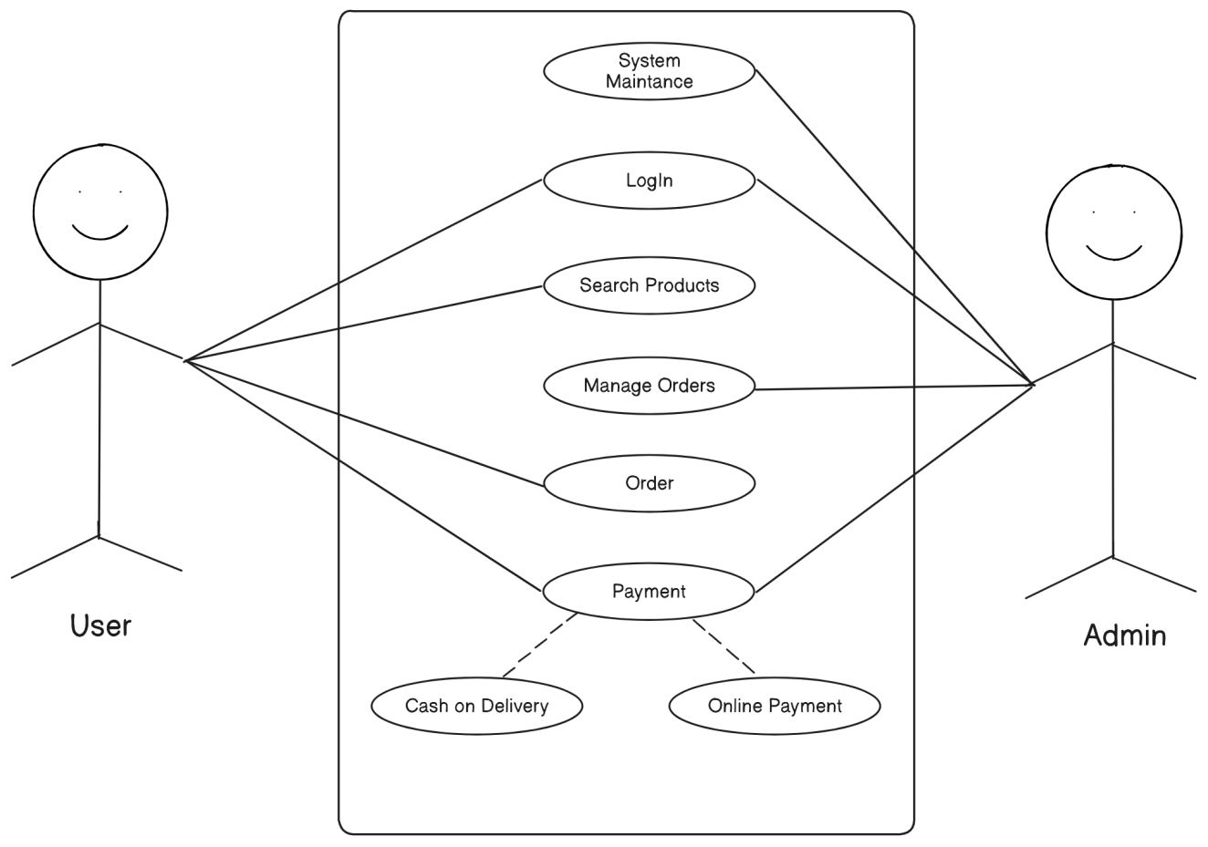**

Figure 1: Use Case

**b. Non-Functional Requirements:**

1. **Performance:** The platform will have fast load times and handle a high number of concurrent users without significant slowdowns.
2. **Scalability:** The system will be able to scale to accommodate increasing numbers of users and product listings.
3. **Security:** The platform will ensure data security with encryption, secure payment processing, and protection against unauthorized access and cyber threats.
4. **Reliability:** The system will be reliable with minimal downtime and robust error handling to ensure continuous operation.
5. **Maintainability:** The platform will be easy to maintain, with a modular architecture that allows for updates and improvements without major disruptions.

### 3.1.2 Feasibility Study

1. Technical Feasibility**:** The necessary hardware and software infrastructure, including servers, databases, and e-commerce platforms, will fully support the website's requirements. By utilizing React, Tailwind, Node.js, and Mongo DB, we ensure the technical feasibility of our platform.
2. Operational Feasibility**:** Our store is equipped with all the features of a modern e-commerce platform, including user-friendly navigation, detailed product descriptions, and responsive customer support, making it highly feasible and efficient in meeting the demands.
3. Economical Feasibility: During this project Electronic gadget store, we will be utilizing all resources at no cost to ensure maximum benefit and value to our project. So, it is economically feasible.
4. 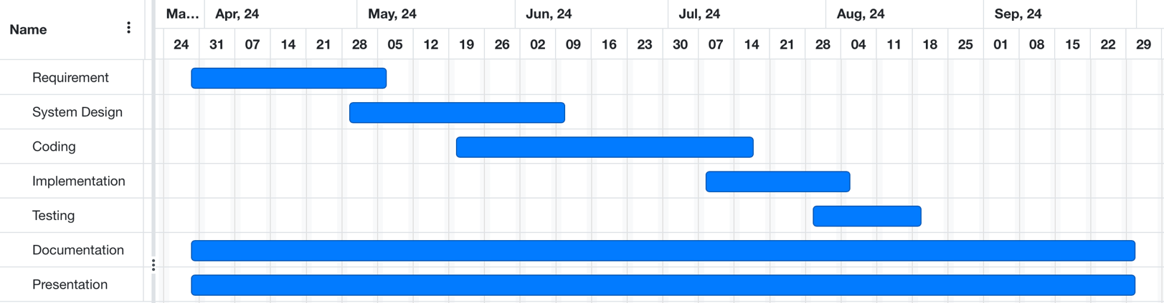Schedule Feasibility: Schedule feasibility of an electronic gadget store has the ability to complete the project within a reasonable timeline, considering factors such as available resources, technology, and project complexity.

Figure 2: Gantt Chart

### 3.1.3 Data Modeling(ER-Diagram)

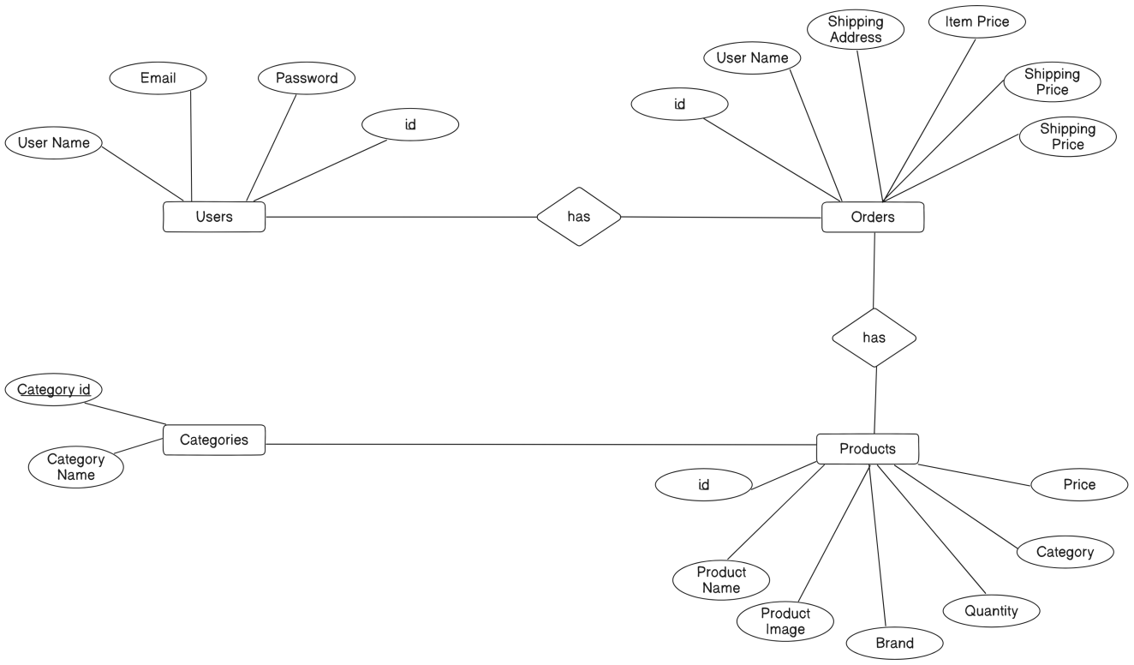

Figure 3: ER – Diagram

### 3.1.4 Process Modeling (DFD)

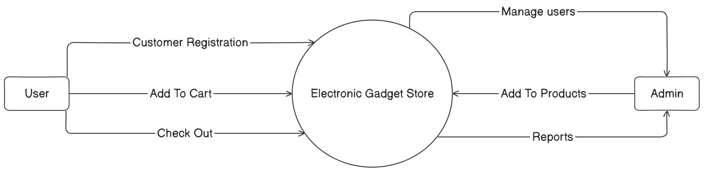

Figure 4: Zero Level DFD

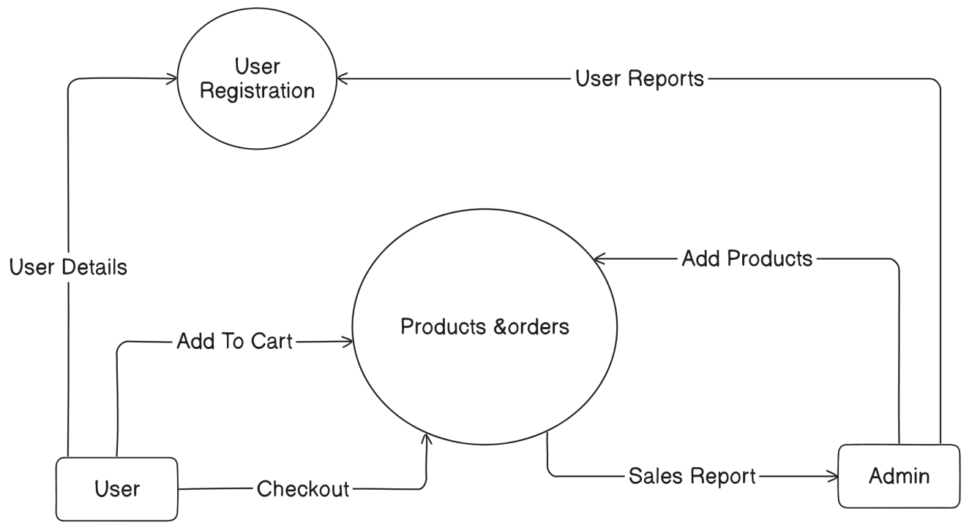

Figure 5: First Level DFD

**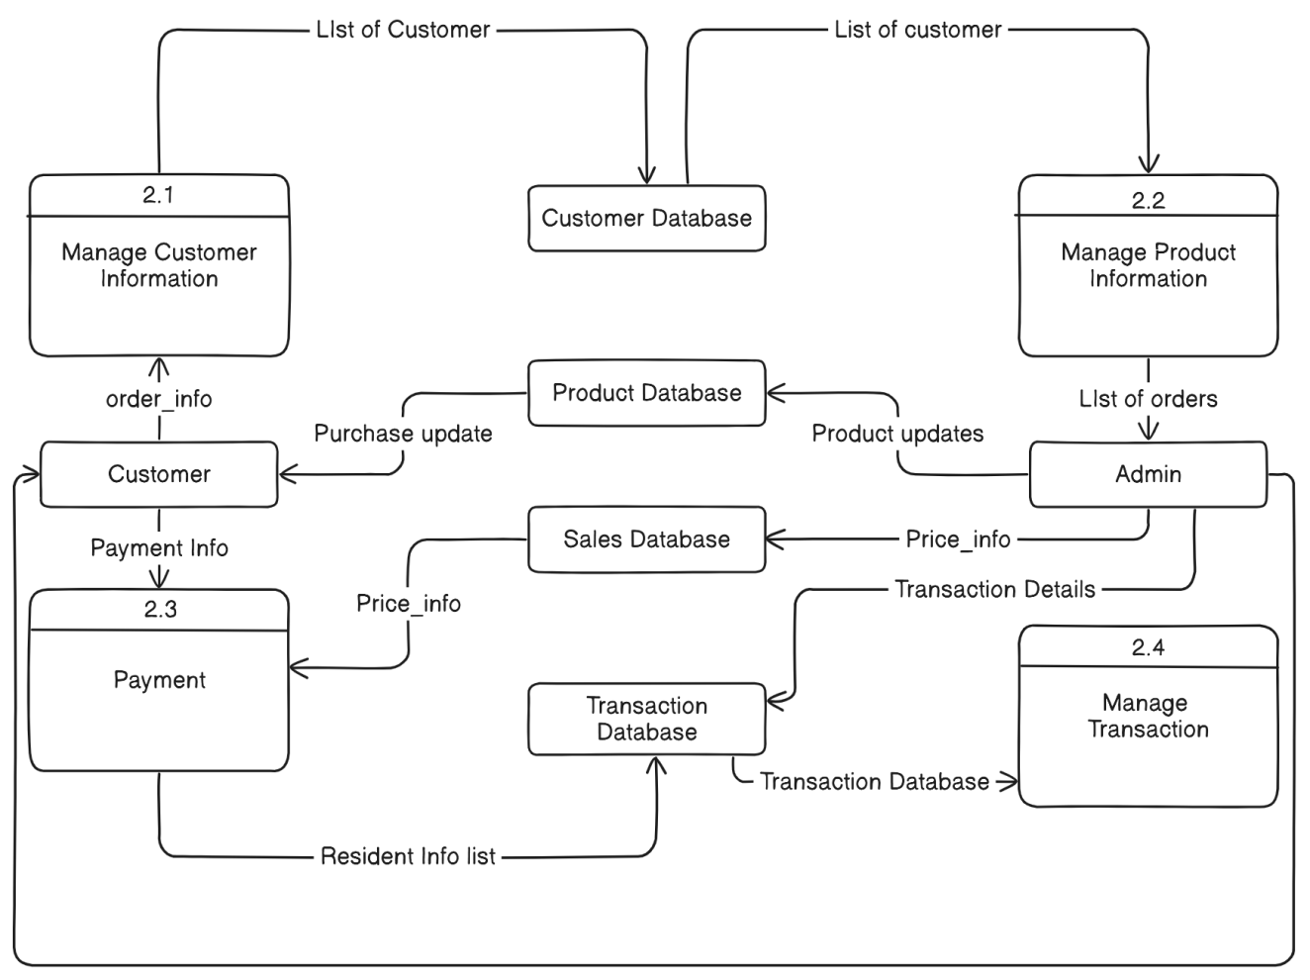**

Figure 6: Second level DFD

## 3.2 System Design

### 3.2.1 Architectural Design

## diagram-export-9-23-2024-8_00_04-AM.png

## Figure 7: Working mechanism of the proposed System

### 3.2.2 Database Schema

Table 1: Orders

|  |  |  |
| --- | --- | --- |
| S No. | Attribute | Datatype |
| 1 | Id | Int |
| 2 | User Name | String |
| 3 | Order Item | String |
| 4 | Shipping Address | String |
| 5 | Item Price | Int |
| 6 | Tax Price | Int |
| 7 | Shipping Price | Int |
| 8 | Total Price | Int |

Table 2: Categories

|  |  |  |
| --- | --- | --- |
| S No. | Attribute | Datatype |
| 1 | id | Int |
| 2 | Category Name | String |

Table 3: Products

|  |  |  |
| --- | --- | --- |
| S No. | Attribute | Datatype |
| 1 | Id | Int |
| 2 | Product Name | String |
| 3 | Brand | String |
| 4 | Quantity | Int |
| 5 | Category | String |
| 6 | Count in-stock | Int |
| 7 | Total Price | Int |

Table 4: Users

|  |  |  |
| --- | --- | --- |
| S No. | Attribute | Datatype |
| 1 | Id | Int |
| 2 | User Name | String |
| 3 | Email | String |
| 4 | Password | String |
| 5 | Is Admin | String |

# Chapter 4: Implementation and Testing

## 4.1 Implementation

### 4.1.1 Tools Used (CASE tools, Programming languages, Database platforms)

1. IDE: Visual Studio Code (VS Code) - A user-friendly and feature-rich integrated development environment (IDE) used for coding and development tasks.
2. Documentation: MS Office - Tools for creating and editing project-related documents and presentations.
3. Version Control: GitHub - A widely-used platform for code repository management and version control, facilitating collaboration and tracking changes.
4. Diagramming: Eraser.io – An online diagramming tool used for creating visual representations, such as system architecture diagrams and UI/UX.
5. Database Management: Mongo DB – A database used to store user information and
6. Front-end: React, Tailwind – Languages used for the development of the electronic gadget store.
7. Back-end: Node.js, Mongo DB – Node.js is a JavaScript runtime used for backend operations, while Mongo DB is used to store users information.

### 4.1.2 Implementation Details of Modules

1. User module implementation: User module functions include user registration, user login, search products, buy products and checkouts.
2. Administrator module implementation: Administrator module functions include login, **product catalog management, order management, inventory management** and manage users.
3. Search Functionality: The search module enables users to quickly find specific products that they are searching for.
4. Profile Management: Users can update their personal information, such as username and profile picture, through this module. It allows users to customize their profile.

## 4.2 Testing

### 4.2.1 Test Cases for Unit Testing

Table 5: Test Case for Unit Testing

|  |  |  |  |  |  |
| --- | --- | --- | --- | --- | --- |
| Test Case No. | Module | Steps | Expected Result | Actual Result | Result |
| TC\_01 | User Registration | Input valid user details and register | User is registered successfully | After Registered users are directed to login page | Pass |
| TC\_02 | User Authentication | Input valid user details and login | User is logged in successfully | User is logged in successfully and directed to home page | Pass |
| TC\_03 | Admin Registration | Input valid Admin details and register | Admin is registered successfully | After registration admin are directed to admin panel | Pass |
| TC\_04 | Cart Management | Test if cart items are displayed correctly | Successfully add to cart | Selected items are added to cart and ready for checkout | Pass |

### 4.2.2 Test Cases for System Testing

System testing is a comprehensive software testing approach that evaluates the entire application rather than individual components. Its goal is to verify that the software meets specified requirements and functions as expected in its intended environment.

Table 6: Test Case for System Testing

|  |  |  |  |  |  |
| --- | --- | --- | --- | --- | --- |
| Test Case No. | Module | Steps | Expected Result | Actual Result | Result |
| TC\_01 | Order Management | Users places the order and pays | Verify that users can view order details and status | Users can place the order details and status | Pass |
| TC\_02 | User & Admin  Registration | Input valid user & Admin data | Successfully registration | Successfully registered with valid data | Pass |
| TC\_03 | Wish list Functionality | Verify that wish list items persist across user sessions | Users can view and manage wish list items | Users can view and manage wish list are their requirements | Pass |

# Chapter 5: Conclusion and Future Recommendations

## 5.1 Lesson Learnt/ Outcome

1. Intuitive Navigation: Users can easily find products through a well-structured navigation system, leading to a pleasant browsing experience.
2. Product Discovery: Features like featured products, related products, and search functionality help users discover gadgets they might be interested in.
3. **Secure Transactions:** SSL certificates and secure payment gateways ensure that users feel safe while making transactions.
4. **Personalized User Accounts:** Account features like order history and enhance user satisfaction by providing personalized experiences.
5. **Order Tracking:** Effective order management tools help track orders from placement to delivery, ensuring timely fulfillment and reducing errors.

## 5.2 Conclusion

Creating an electronic gadgets store can meet the rising demand for tech products. Offering a wide range of gadgets, secure shopping, and good customer support will attract customers. However, challenges like competition, stock management, and rapid tech changes require careful planning. Success will depend on strong security, efficient delivery, and balancing opportunities with these challenges.

## 5.3 Future recommendations

1. Offer Tech Support Services: Provide after-sales support services like online tech help, setup guides, or paid repair services.
2. **AI and Personalization:** Implement AI-driven recommendations based on customer browsing and purchasing behavior.
3. **Augmented Reality (AR):** Develop an AR feature allowing customers to view products in their environment (e.g., how a TV fits on their wall).
4. **Enhanced Delivery Options:** Partner with local logistics services to offer same-day or express delivery for select regions.
5. **Customer Loyalty Program:** Create a points-based loyalty program where customers earn rewards for each purchase.

**REFERENCE**

[1]“Hukut Store - Authentic Gadget Store in Nepal,” *Hukut Store - Authentic Gadget Store in Nepal*. https://hukut.com/ (accessed Jul. 17, 2024).

[2]SajiloShop, “The Best Gadgets and Accessories Online | SajiloShop,” *sajiloshop.com.np*. https://sajiloshop.com.np/ (accessed Jul. 17, 2024).

[3]“Alpha Store Nepal,” *Alpha Store Nepal*. https://alphastorenepal.com/ (accessed Jul. 17, 2024).

# Appendices

